Account Maker Agreement
Este code ya estaba el client desde hace mucho, pero estaba desactivado. Lo que hice fue reactivarlo, y mejorar un poquito la parte visual, ya que desde hace varias versiones que sacaron el sprite que usaba. Les dejo una foto de como queda:
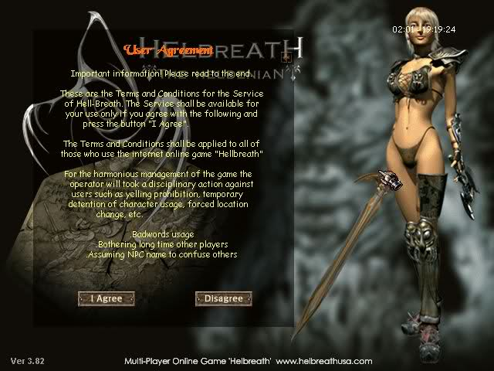
ClientSRC:
Game.cpp:
Buscar:
Código:
case DEF_GAMEMODE_ONAGREEMENT:
y deberian ver algo asi:
Código:
case DEF_GAMEMODE_ONAGREEMENT:
//UpdateScreen_OnAgreement(); //unused by HBx server..
break;
remplacen todo ese case por:
Código:
//50Cent - Agreement back
case DEF_GAMEMODE_ONAGREEMENT:
UpdateScreen_OnAgreement();
break;
Buscar:
Código:
//ChangeGameMode(DEF_GAMEMODE_ONAGREEMENT);
ChangeGameMode(DEF_GAMEMODE_ONCREATENEWACCOUNT);
y modifiquen esas dos lineas por:
Código:
//50Cent - Agreement back
ChangeGameMode(DEF_GAMEMODE_ONAGREEMENT);
//ChangeGameMode(DEF_GAMEMODE_ONCREATENEWACCOUNT);
Luego busquen nuevamente:
Código:
//ChangeGameMode(DEF_GAMEMODE_ONAGREEMENT);
ChangeGameMode(DEF_GAMEMODE_ONCREATENEWACCOUNT);
y remplacen esas dos lineas por:
Código:
//50Cent - Agreement back
ChangeGameMode(DEF_GAMEMODE_ONAGREEMENT);
//ChangeGameMode(DEF_GAMEMODE_ONCREATENEWACCOUNT);
Ahora vayan al metodo:
Código:
void CGame::UpdateScreen_OnAgreement()
y lo remplazan por este:
Código:
void CGame::UpdateScreen_OnAgreement()
{
short sX, sY, msX, msY, msZ;
char cLB, cRB;
char cMIresult;
static class CMouseInterface * pMI;
int i, iTotalLines, iPointerLoc;
DWORD dwTime = timeGetTime();
double d1,d2,d3;
int iMIbuttonNum;

sX = 121;
sY = 22;

if (m_cGameModeCount == 0) {
m_iAgreeView = 0;
_LoadAgreementTextContents(0);

pMI = new class CMouseInterface;
pMI->AddRect(sX+82 -105, sY+355,sX+131 -105,sY+374);
pMI->AddRect(sX+235 -105, sY+355,sX+303 -105,sY+375);
}

m_cGameModeCount++;
if (m_cGameModeCount > 100) m_cGameModeCount = 100;
if (m_bEnterPressed == TRUE) {
PlaySound('E', 14, 5);
ChangeGameMode(DEF_GAMEMODE_ONCREATENEWACCOUNT);
ClearContents_OnCreateNewAccount();
delete pMI;
return;
}
if (m_bEscPressed == TRUE) {
PlaySound('E', 14, 5);
ChangeGameMode(DEF_GAMEMODE_ONMAINMENU);
delete pMI;
m_bEscPressed = FALSE;
return;
}
m_DInput.UpdateMouseState(&msX, &msY, &msZ, &cLB, &cRB);
m_DDraw.ClearBackB4();
DrawNewDialogBox(DEF_SPRID_INTERFACE_ND_NEWACCOUNT, 0,0,0, TRUE);

iMIbuttonNum = pMI->iGetStatus(msX, msY, cLB, &cMIresult);
if (cMIresult == DEF_MIRESULT_CLICK) {
switch (iMIbuttonNum) {
case 1: // Agree
PlaySound('E', 14, 5);
ChangeGameMode(DEF_GAMEMODE_ONCREATENEWACCOUNT);
ClearContents_OnCreateNewAccount();
delete pMI;
return;

case 2: // Disagree
PlaySound('E', 14, 5);
ChangeGameMode(DEF_GAMEMODE_ONMAINMENU);
delete pMI;
return;
}
}

m_DDraw.DrawShadowBox(43,38,380,422);
PutString_SprFont(160, 55, "User Agreement", 50, 25, 0);
/*DrawNewDialogBox(DEF_SPRID_INTERFACE_ND_AGREEMENT, 0,0,0, TRUE);
DrawNewDialogBox(DEF_SPRID_INTERFACE_ND_TEXT, 43, 38,12, FALSE);

DrawNewDialogBox(DEF_SPRID_INTERFACE_ND_GAME2, 100, 100, 2);
DrawNewDialogBox(DEF_SPRID_INTERFACE_ND_TEXT , 100, 100, 4);*/

iTotalLines = 0;
for (i = 0; i < DEF_TEXTDLGMAXLINES; i++)
if (m_pAgreeMsgTextList[i] != NULL) iTotalLines++;

d1 = (double)m_iAgreeView;
d2 = (double)(iTotalLines - 20);
d3 = (double)d1 / d2;
d1 = 338.0f * d3;
iPointerLoc = (int)d1;
//m_pSprite[DEF_SPRID_INTERFACE_ND_GAME2]->PutSpriteFast(sX +361 -112, sY +37 +13 +iPointerLoc, 7, dwTime);
DrawNewDialogBox(DEF_SPRID_INTERFACE_ND_GAME2, sX + 361 - 112, sY + 37 + 13 + iPointerLoc, 7, FALSE, TRUE);

for (i = 0; i < 20; i++)
if (m_pAgreeMsgTextList[i + m_iAgreeView] != NULL) {
PutAlignedString(60, 360, sY + 65 +i*13, m_pAgreeMsgTextList[i + m_iAgreeView]->m_pMsg, 255,255,135);
}

if( msZ != 0 )
{
m_iAgreeView = m_iAgreeView - msZ/60;
m_DInput.m_sZ = 0;
}
if (cLB != 0 && iTotalLines > 20)
{ if ((msX >= sX +345 -112) && (msX <= sX +380 -112) && (msY >= sY +50) && (msY <= sY +395))
{ d1 = (double)(msY - (sY + 37 +13));
d2 = (double)(iTotalLines - 17);
d3 = (double)(d1 * d2)/(338.0f);
m_iAgreeView = (int)d3;
} }
if( m_iAgreeView < 0 ) m_iAgreeView = 0;
if( iTotalLines > 20 && m_iAgreeView > iTotalLines-20 ) m_iAgreeView = iTotalLines-20;

if ((msX > sX + 82 -105) && (msX < sX + 131 -105) && (msY > sY + 355 -3) && (msY < sY + 374 +3))
DrawNewDialogBox(DEF_SPRID_INTERFACE_ND_BUTTON, sX + 43 + 20 -23 +45 -105, sY + 265 +90, 13);
else DrawNewDialogBox(DEF_SPRID_INTERFACE_ND_BUTTON, sX + 43 + 20 -23 +45 -105, sY + 265 +90, 12);

if ((msX > sX + 235 -105) && (msX < sX + 303 -105) && (msY > sY + 355 -3) && (msY < sY + 375 +3))
DrawNewDialogBox(DEF_SPRID_INTERFACE_ND_BUTTON, sX + 158 + 57 -23 +45 -105, sY + 265 +90, 15);
else DrawNewDialogBox(DEF_SPRID_INTERFACE_ND_BUTTON, sX + 158 + 57 -23 +45 -105, sY + 265 +90, 14);

DrawVersion();
m_pSprite[DEF_SPRID_MOUSECURSOR]->PutSpriteFast(msX, msY, 0, dwTime);

// if (m_cGameModeCount < 6) m_DDraw.DrawShadowBox(0,0,639,479);
// if (m_cGameModeCount < 2) m_DDraw.DrawShadowBox(0,0,639,479);

if (m_DDraw.iFlip() == DDERR_SURFACELOST) RestoreSprites();
}
Para modificar el texto deben editar sus contents, la verdad que nunca me puse a ver cual era asique se los dejo para que lo descubran .
// Post original de ComunidadMH.com: http://www.comunidadmh.com/showthread.php?353-Account-Maker-Agreement#ixzz2EQFrDiGi

